**INVITATION**

**au 15ème Séminaire AdiHainaut**

**Spa**

**Du lundi 1 au jeudi 4février 2016**

L’**AdiHainaut**est uneAssociation qui regroupe les directeurs de l’enseignement secondaire catholique du Diocèse du Hainaut en Belgique.

Chaque année, elle organise un séminaire qui accueille près d’une centaine de participants. Différents ateliers sont présentés sur des thématiques différentes.

Pour l’édition 2016, trois ateliers auront pour thème le **LEADERSHIP**. Ces trois ateliers pourront accueillir des invités européens.

L’AdiHainaut espère, par cette démarche, promouvoir les relations européennes et les échanges entre directions scolaires.

Bienvenue à tous

1. **Présentation des ateliers**

***Vous trouverez ci-dessous la description des trois ateliers organisés en anglais***

***Workshop 1*Be a conscious leader with Jean-Michel BOCQUE**

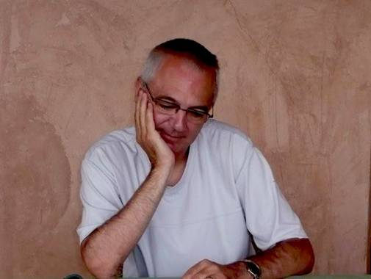

The impact and the effectiveness of one's leadership depends on the consciousness that one has about one's own ways of operating.

Before managing others, it is important to know how to manage oneself.

The presence of a leader with good interpersonal skills generates a pleasant school climate and makes it easier to develop changes within the education staff.

This training session will providea good understanding of your own skills and weaknesses in the fields of management and interpersonal communication. Therefore each participant will receive a folder that describes his communicativebehaviour patterns.

General objectives of the training

• To know oneself better

• To have a better knowledge of others

• To build a team synergy through motivation

• To reconcilepersonal project and school project

• To learn to take advantage of the differences between the members of a team

Before the training

Online quiz to discover your personal profile

Specific objectives during the training

• To understand, integrateand implement the model ;

• To understand one's strengths andweaknesses ;

• To managea team with effectiveness by quickly understanding the profile of one's staff;

• To optimize the strengths of one's staff by finding the keys to consolidate the coherenceand the collective intelligence;

To accelerate the decisionmaking and to motivate in a focused way ;

To adapt your way of communication and your management

Trainer's experience

Jean-Michel Boqué, a psycho-sociologist,has trained many school managers in the field of leadership, analysis of organizations and evolution of human values.

***Workshop 2*"How neuroscience can help you make a better use of your brain to manage your team and school” with Diane THIBAUT**

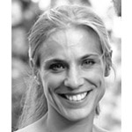

As any School Principal, you go under stress in certain circumstances while in others you feel serene and efficient. What really happens in your brain? How can you reduce the amount of stress that you experience?

In everyday life, the brain uses two different mindsets: the automatic mode and the adaptive one. The automatic mode is efficient enough to handle simple and familiar situations. In complex or unknown situations however, the adaptive mode is required. If your brain persists in using the inappropriate mode, you might go under stress and manage your team and your school inefficiently.

Stress is an instinctive global reaction that generates unpleasant symptoms and according to all research alters thinking and acting abilities. You are thus less efficient in achieving your goals. To reduce stress and maintain serenity, you need to mobilize the adaptive mode.

The purpose of the workshop is to help you understand the mechanisms behind stress and lead you toswitch from the automatic mode to the adaptive one.

Consisting of a little theory and a lot of exercises and case studies, the workshop will offer you practical tools to be used in your everyday life, helping you lead your team and school without stress in a constantly changing environment.

**Workshop3CREATIVE LEADERSHIP with Philippe BRASSEUR**

[**www.philippebrasseur.be**](http://www.philippebrasseur.be) **www.creativita.be**

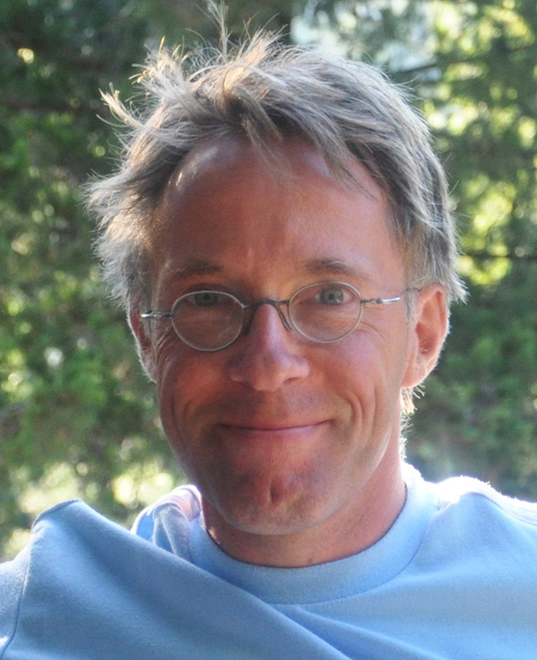

This participative, exciting workshop is about the why and how of creative leadership. It will follow a structured path : why creativity matters in schools (and leadership) today - Some effective techniques to think in new ways - The essential link between creativity and pedagogy - Managing creativity throughout your organization - How to facilitate productive brainstorming - What about your own everyday creativity?

A great leader shows the goal, but lets everyone find his own way to it. This is paradoxical management: it requires to sail between freedom and constraint, open-mindedness and structure, uncertainty and faith, logic and intuition… In times of rapid and unpredictable changes, creativity is no side-competence for leaders and organizations anymore. It is vital.

The trainer brings his triple experience of creativity in teaching, leadership and the arts. This specific workshop aims at creating a joyful experience of personal and group creativity, all serving the aims of school directors. Participants will work on their own questions / challenges, using a variety of approaches in a sphere of "serious play".

Participants will be more "consciously creative". Having mastered the attitudes and techniques of creative thinking, they will use them in well-structured processes of problem-solving or project management. They will also   find ways to cultivate a genuine creative climate throughout the school community. More fundamentally still, they will experience that, as Carl Rogers put it, "In its deepest meaning, being creative means fulfilling oneself as a human being."

1. **Modalités pratiques**

**La personne de contact :**

Jean-Claude PIERRE jcl.pierre@skynet.be

Institut Saint-Augustin

Chaussée d’Ath 1 7850 ENGHIEN

✆ 02/3970260 🖃 saint.augustin.enghien@skynet.be

**Le coût :**

La participation au séminaire est de **850€**et comprend le logement en chambre single et la pension complète, les locations de salles, de matériel, ainsi que les honoraires des formateurs. Il ne comprend pas les boissons consommées au bar, ni lors des repas en sus du forfait.

***A verser sur le compte BE87 270013787894 de l’ADIHAINAUT***

**L’hébergement :**

**DOMAINE SOL CRESS**

**Spaloumont, 5 | B-4900 Spa - Belgique  
Tél. 087 77 23 53 - Fax 087 77 48 93**

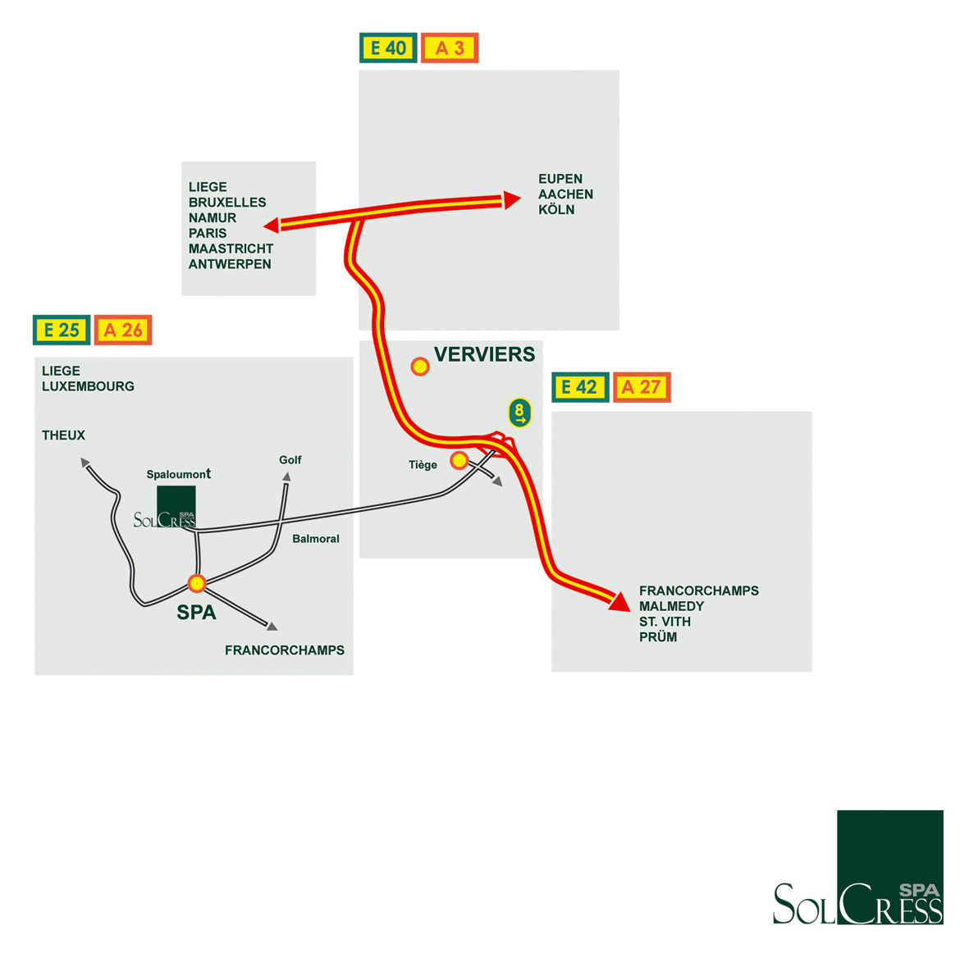

**Programme 2016**

**Lundi 1février C:\Documents and Settings\baudry\Local Settings\Temporary Internet Files\Content.IE5\CVRSQ8XN\MC900343619[1].wmf**

18h00 – 19h00 : accueil des participants

19H30 : repas

20h30 : présentation du séminaire par Patricia POTIGNY

20h45 : intervention d’Eric DAUBIE sur l’actualité

.

**Mardi 2 février**

7H30 à 8H30 : petit déjeuner

09H00 : 1ère séance de travail

10H30 : pause

10H50 : 2èmeséance de travail

12H15 : repas

13H30 : 3èmeséance de travail

15H30 : pause

16H00 : 4èmeséance de travail

17H30 : pause

18h30 : apéritif

19h30 : repas

21h00 : soirée surprise

**Mercredi 3février**

7H30 à 8H30 : petit déjeuner

09H00 : 5èmeséance de travail

10H30 : pause

10H50 : 6èmeséance de travail

12H15 : repas

13H30 : 7ème séance de travail

15H00 : activités ou temps libre

19H30 : repas

21H00 : soirée « le grand Benito »

C:\Documents and Settings\baudry\Local Settings\Temporary Internet Files\Content.IE5\VVK9EQ1F\MC900435436[1].wmf



**Jeudi 4 février**

7H30 à 8H30 : petit déjeuner

09H00 : 8ème séance de travail

10H30 : pause

10H50 : dernière séance de travail (9ème)

12H00 : évaluation du séminaire en atelier

12h15 : apéritif

13H00 : repas et fin du séminaire